

LAPORAN PRAKTIKUM

PRAKTIKUM ORGANISASI ARSITEKTUR KOMPUTER

MODUL : 03

“ BINER, GERBANG LOGIKA, DAN ADDER ”

NAMA : ALFANSYAH PUTRA RAJA DINATA

NIM : L0223002

HARI : JUM’AT

TANGGAL : 22 SEPTEMBER 2023

WAKTU : 07.30 – 9.15

ASISTEN : MUHAMMAD FIKRI ABDULLAH

MUHAMMAD SYAFIQ IBRAHIM

PROGRAM STUDI SAINS DATA

FAKULTAS TEKNOLOGI INFORMASI DAN SAINS DATA

UNIVERSITAS SEBELAS MARET

2023

Modul 3

BINER, GERBANG LOGIKA, DAN ADDER

**ALFANSYAH PUTRA RAJA DINATA** (L0223002) / Jum’at, 22 September 2023

Email : [alfansyahprd@student.uns.ac.id](mailto:alfansyahprd@student.uns.ac.id)

Asisten :

Muhammad Fikri Abdullah

Muhammad Syafiq Ibrahim

**KEGIATAN 1**

Mengerjakan 6 soal biner beserta tahapannya.

1. 100 + 111 = 4 + 7 ( Decimal )

= 11 ( Decimal ) = **1100 ( Biner )**

1. 1001 – 101 = 9 – 5 ( Decimal )

= 4 ( Decimal ) = **100 ( Biner )**

1. 100 x 101 = 4 x 5 ( Decimal )

= 20 ( Decimal ) = **10100 ( Biner )**

1. 10010 / 1001 = 18 / 9 ( Decimal )

= 2 ( Decimal ) = **10** **( Biner )**

1. (110 – 10) x 11 = ( 6 – 2 ) x 3 ( Decimal )

= 4 x 3 ( Decimal )

= 12 ( Decimal ) = **1100 ( Biner )**

1. (110 + 100) / 101 = ( 6 + 4 ) / 5 ( Decimal )

= 10 / 5 ( Decimal )

= 2 ( Decimal ) = **10 ( Biner )**

**KEGIATAN 2**

1. Gerbang NAND

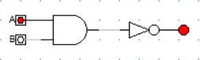

1. Gerbang NOR

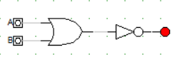

1. 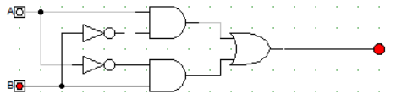Gerbang XOR
2. Gerbang XNOR

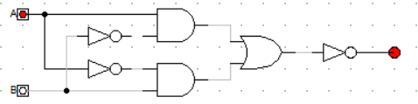

**KEGIATAN 3**

1. HALF ADDER

|  |  |  |  |  |  |
| --- | --- | --- | --- | --- | --- |
| NO | GAMBAR | A | B | SUM | CARRY |
| 1 |  | 0 | 0 | 0 | 0 |
| 2 |  | 1 | 0 | 1 | 0 |
| 3 |  | 0 | 1 | 1 | 0 |
| 4 |  | 1 | 1 | 0 | 1 |

1. FULL ADDER

|  |  |  |  |  |  |  |
| --- | --- | --- | --- | --- | --- | --- |
| NO | GAMBAR | A | B | CARRY IN | CARRY OUT | SUM |
| 1 |  | 0 | 0 | 0 | 0 | 0 |
| 2 |  | 1 | 0 | 0 | 0 | 1 |
| 3 |  | 0 | 1 | 0 | 0 | 1 |
| 4 |  | 0 | 0 | 1 | 0 | 1 |
| 5 |  | 1 | 1 | 0 | 1 | 0 |
| 6 |  | 1 | 0 | 1 | 1 | 0 |
| 7 |  | 0 | 1 | 1 | 1 | 0 |
| 8 |  | 1 | 1 | 1 | 1 | 1 |

**Alfansyah Putra Raja Dinata**

Seorang pelajar yang suka belajar hal baru, khususnya di bidang komputer, terutama di bidang perangkat lunak (software), termasuk custom ROM dan custom Windows. Memiliki hobi fotografi di bidang arsitektur dan street photography. Ketika bosan, suka melakukan perjalanan (touring) sampai ke pelosok entah berantah hanya untuk mencari hal baru.